Probability Density Function (pdf)
A probability density function is an equation used to compute probabilities of continuous random variables. It must satisfy the following two properties:

1. The total area under the graph of the equation over all possible values of the random variable must equal 1.

2. The height of the graph of the equation must be greater than or equal to 0 for all possible values of the random variable.

Relationship between areas and probabilities
The area under the graph of a density function over an interval represents the probability of observing a value of the random variable in that interval.

Definition – A continuous random variable is normally distributed, or has a normal probability distribution, if
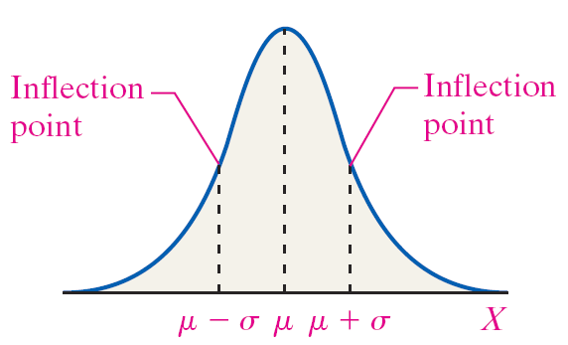
its relative frequency histogram has the shape of a normal curve.
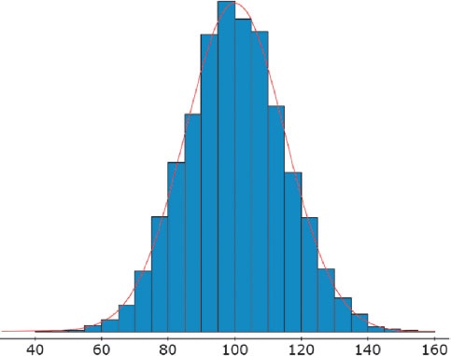

Note: Inflection points are the points on the curve where the curvature (or concavity) of the graph changes.

Properties of the Normal Density Curve

1. It is symmetric about its mean, μ.

2. Because mean = median = mode, the curve has a single peak and the highest point occurs at x = μ.

3. It has inflection points at μ – σ and μ + σ.

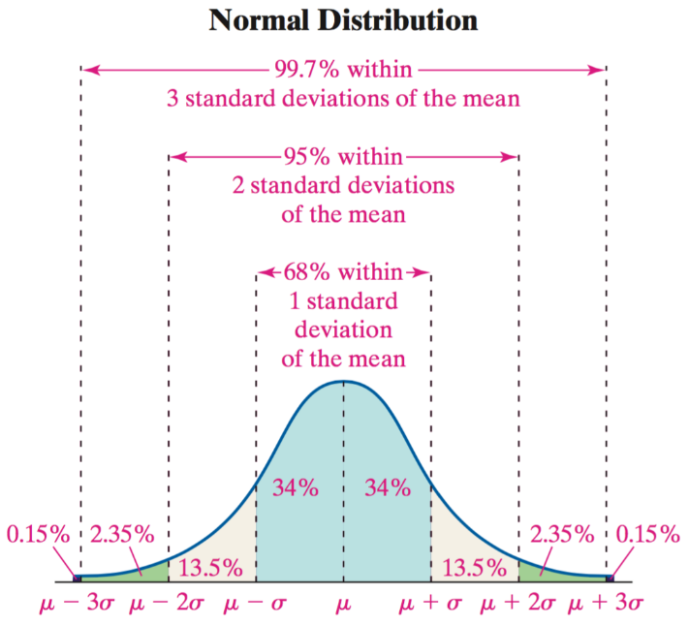
4. The area under the curve is 1.

5. The area under the curve to the right of μ equals the area
Under the curve to the left of μ, which equals .

6. As x increases without bound (gets larger and larger), the
graph approaches, but never reaches, the horizontal axis.
As x decreases without bound (gets more and more negative),
the graph approaches, but never reaches, the horizontal axis.

7. The Empirical Rule:
Approximately 68% of the area under the normal
curve is between x = μ – σ and x = μ + σ;
approximately 95% of the area under the normal
curve is between x = μ – 2σ and x = μ + 2σ;
approximately 99.7% of the area under the normal
curve is between x = μ – 3σ and x = μ + 3σ.

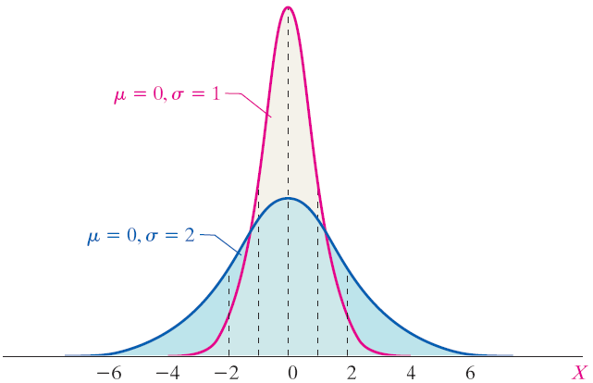
Examples and comparisons of normal distributions

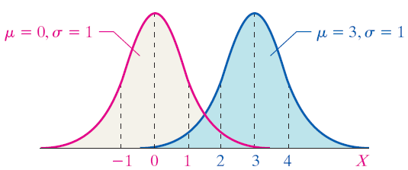

Here, we can see that increasing the mean from 0 to 3 caused the graph to shift three units to the right but maintained its shape.
Here, we can see that increasing the standard deviation from 1 to 2 caused the graph to become flatter and more spread out but maintained its location of center.

Area Under a Normal Curve
Suppose that a random variable X is normally distributed with mean μ and standard deviation σ. The area under the normal curve for any interval of values of the random variable X represents either

• the proportion of the population with the characteristic described by the interval of values or

• the probability that a randomly selected individual from the population will have the characteristic described by the interval of values.

Exercises:

1) Uniform Distribution. The reaction time X (in minutes) of a certain chemical process follows a uniform probability distribution with 5 ≤ X ≤ 10.

a) Draw the graph of the density curve.

b) What is the probability that the reaction time is between 6 and 8 minutes?

c) What is the probability that the reaction time is between 5 and 8 minutes?

d) What is the probability that the reaction time is less than 6 minutes?

Exercises:

For Exercises #2 and #3, determine whether or not the histogram indicates that a normal distribution could be
used as a model for the variable.
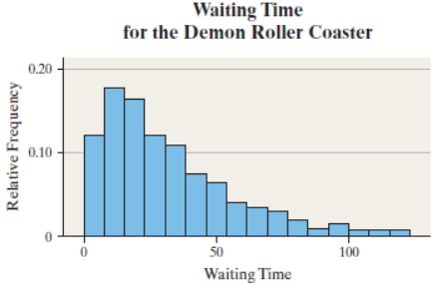

2) Waiting in Line. The relative frequency histogram
represents the waiting times (in minutes) to ride the
Demon Roller Coaster for 2000 randomly selected
people on a Saturday afternoon in the summer.

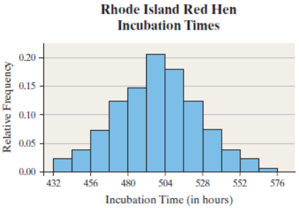

3) Incubation Times. The relative frequency histogram
represents the incubation times of a random sample
of Rhode Island Red hens’ eggs.

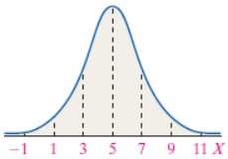
4) The graph of a normal curve is given. Use the
graph to identify the values of μ and σ.

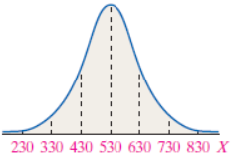
5) The graph of a normal curve is given. Use the
graph to identify the values of μ and σ.

Exercises:

6) Draw a normal curve with μ = 30 and σ = 10. Label the mean and the inflection points.

7) Refrigerators. The lives of refrigerators are normally distributed with mean, μ = 14 years and standard deviation σ = 2.5 years.

Source: Based on information from Consumer Reports.
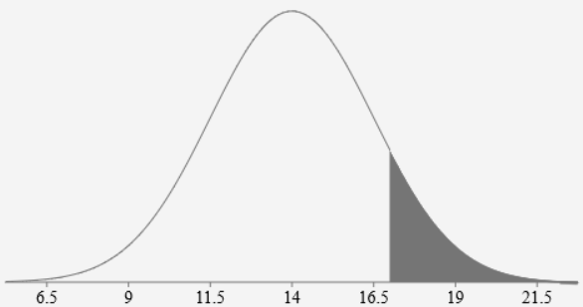
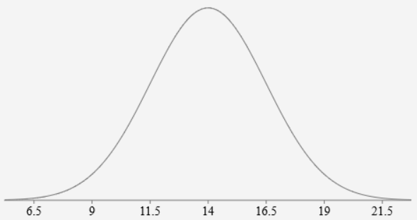
a) Draw a normal curve with the parameters labeled.

b) Shade the region that represents the proportion of refrigerators that last for more than 17 years.

c) Suppose the area under the normal curve to the right of x = 17 is 0.1151. What is the probability that refrigerator will last more than 17 years?

d) What is the probability that refrigerator will last less than 17 years?

