Normal Distribution
A probability distribution that plots all of its values in a symmetrical fashion and most of the results are situated around the probability’s mean is called a normal distribution. Values are equally likely to plot either above or below the mean. Grouping takes place at values that are close to the mean and then tails off symmetrically away from the mean.
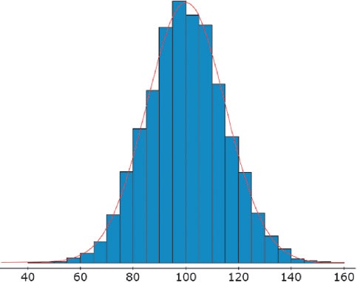

Some Properties of a Normal Distribution
1. The value in the middle of the distribution, which appears most often in the sample, is the mean.
2. The distribution is symmetric about the mean. This means that the graph has two halves that are mirror images on either side of the mean value.
3. This is the key fact: the area under any portion of the curve is the percentage (in decimal form) of data values that fall between the values that begin and end that region.
4. The total area under the entire curve is 1.

Exercises:

1) The graph below shows a normal distribution for heights of women in the United States. The numbers on the horizontal axis are heights in inches, and some areas are labeled for reference.
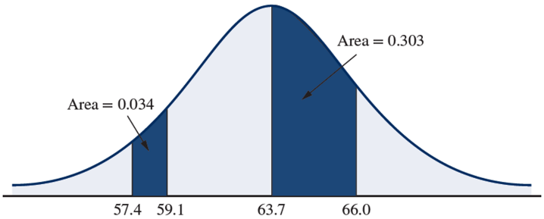

a) What is the mean height?

63.7 inches

b) What percentage of women are between 57.4 and 59.1 inches tall?

3.4%

c) If there are 31,806 women at a stadium concert, how many of them would you expect to be
between 63.7 and 66.0 inches tall?

0.303 × 31,806 = 9637.218 ≈ 9637 women

The Empirical Rule or (The 68-95-99.7 Rule)
If a distribution is normally distributed, then

Approximately 68% of the data will lie within 1 standard deviation to either side of the mean. That is, approximately 68% of the data lie between $\overline{x}-1s$ and $\overline{x}+1s$ (or simply $\overline{x}-s$ and $\overline{x}+s$).

Approximately 95% of the data will lie within 2 standard deviations to either side of the mean. That is, approximately 95% of the data lie between $\overline{x}-2s$ and $\overline{x}+2s$.

Approximately 99.7% of the data will lie within 3 standard deviations to either side of the mean. That is, approximately 99.7% of the data lie between $\overline{x}-3s$ and $\overline{x}+3s$.
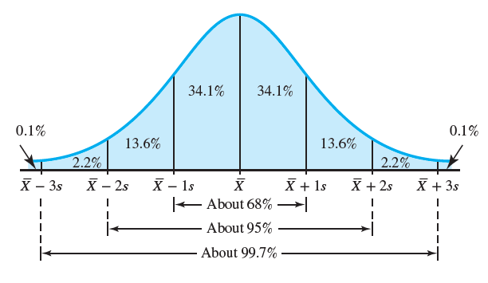

Exercises:

2) The mean lifetime of a particular LED light bulb is 3000 hours with a standard deviation of 700 hours. The bulb life has a normal distribution.

a) 68% of all manufactured light bulbs will last between __________ and __________ hours.

b) 95% of all manufactured light bulbs will last between __________ and __________ hours.

c) 99.7% of all manufactured light bulbs will last between __________ and __________ hours.

3) The Empirical Rule. SAT Math scores have a normal distribution with a mean of 515 and a standard deviation of 114.

Source: College Board, 2010

a) What percentage of SAT scores is between 401 and 629?

b) What percentage of SAT scores is less than 401 or greater than 629?

c) What percentage of SAT scores is greater than 743?

The Standard Normal Distribution
The standard normal distribution is a normal distribution with mean 0 and standard deviation 1.
The values under the curve shown indicate the proportion of area in each section.
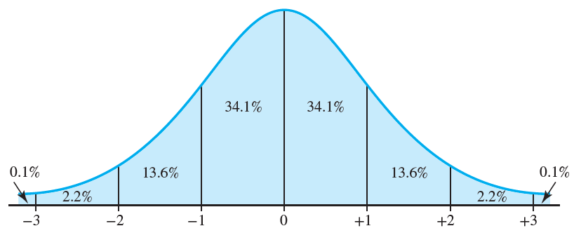

z-Score
For a data value from a sample with mean $\overline{x}$ and standard deviation s, the z score is

$$z=\frac{X-\overline{x}}{s}$$

Verbally, to find a z-score, just subtract the mean, then divide the result by the standard deviation.

Note: A data point is greater than the mean if z > 0 and less than the mean if z < 0. z-scores are typically rounded to two decimal places.

Exercises:

4) Find the z-score for the value 150, when the mean is 180 and the standard deviation is 10.

5) Find the z-score for the value 104, when the mean is 92 and the standard deviation is 8.

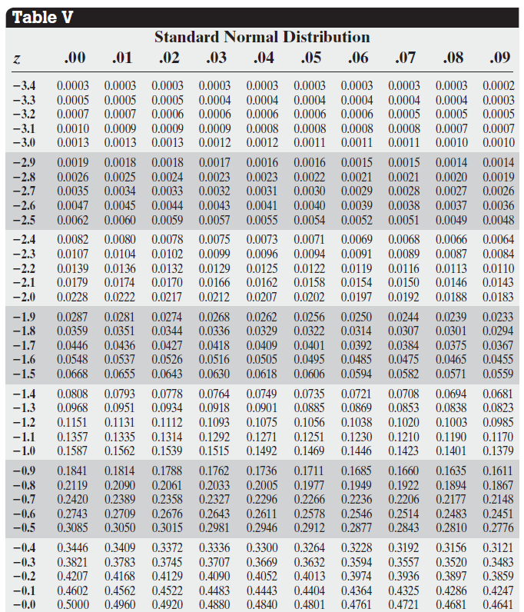

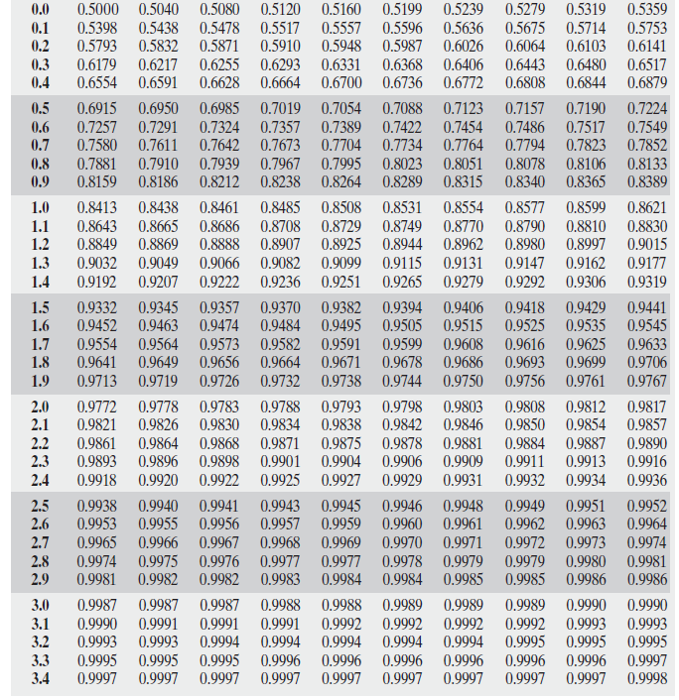

Use Table V to obtain the areas under the standard normal curve. Sketch a standard normal curve and shade the area of interest in each problem.

Example #1:
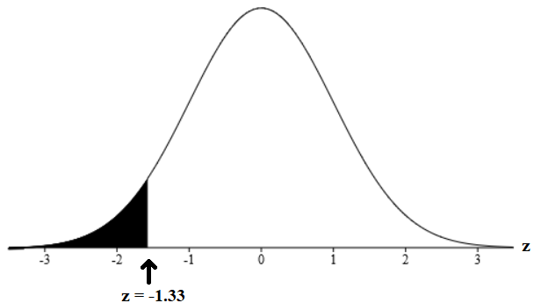
Determine the area under the standard normal curve that lies to the left of –1.33.

Symbolically, we can write P(z < –1.33).

Shade the region of interest on the standard normal curve
as shown in the figure to the right.

Now, we look at Table V.
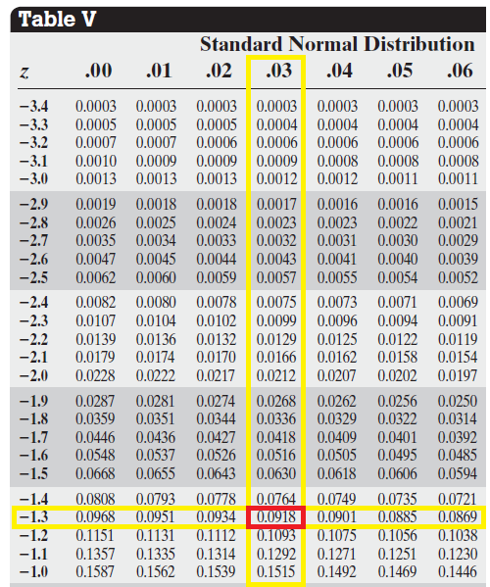
Table V displays z-scores ranging from – 3.49 to 3.49. The ones and tenths digits are located in the leftmost column and the hundredths digits along the top row in bold. The corresponding areas are listed in the center rounded to the nearest ten-thousandths. A portion of Table V is shown to the right.

Our goal is to find the area corresponding to the value
of –1.33.

So, we locate the row corresponding to the value of the
tenths place of –1.33 in the first column.

That would be –1.3.

Next, we go to the column corresponding to the value of the
hundredths place, which is .03.

As you can see, the corresponding area to the z-score
of –1.33 is 0.0918.

NOTE: The areas displayed in the middle of Table V represents the area to the LEFT of the specified z-score.

So, since our original question was pertaining to finding the area to the left of the z-score –1.33, then the answer is that corresponding area which is 0.0918.

Thus, the area under the standard normal curve that lies to the left of –1.33 is 0.0918.
Similarly,. P(z < –1.33) = 0.0918

Exercises:
Use Table V to obtain the areas under the standard normal curve. Sketch a standard normal curve and shade the area of interest in each problem.
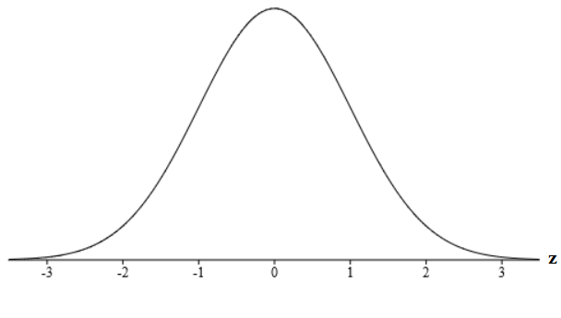
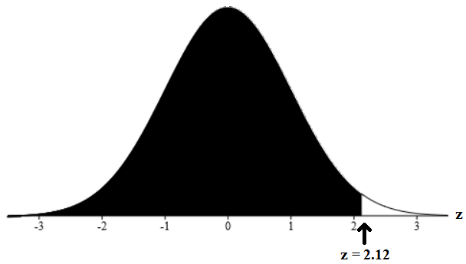
6) Determine the area under the standard
normal curve that lies to the left of 2.12.

$$P(z<2.12)=0.9830$$

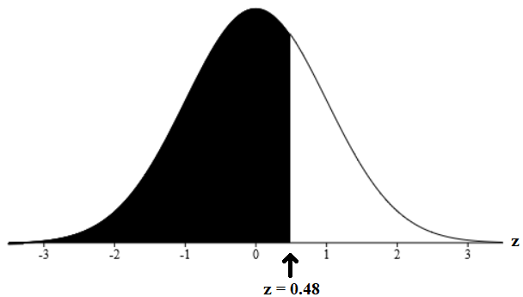
7) Determine the area under the standard
normal curve that lies to the left of 0.48.

$$P(z<0.48)=0.6844$$

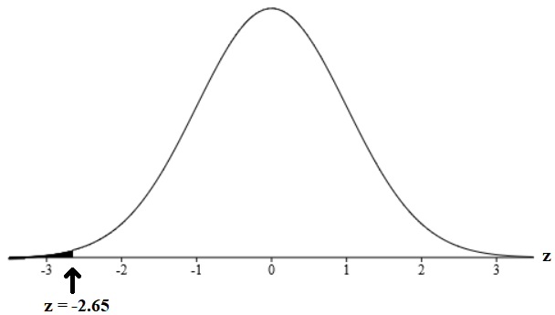
8) Determine the area under the standard
normal curve that lies to the left of –2.65.

$$P(z<-2.65)=0.0040$$

Use Table V to obtain the areas under the standard normal curve. Sketch a standard normal curve and shade the area of interest in each problem.

Example #2:
Determine the area under the standard normal curve that lies to the right of 0.25.
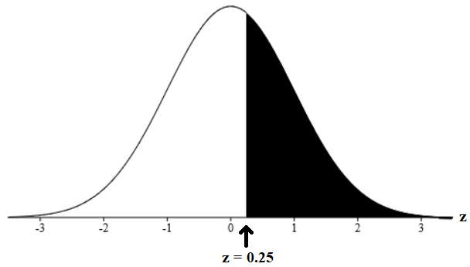

Symbolically, we can write P(z > 0.25).

Shade the region of interest on the standard normal curve
as shown in the figure to the right.

Now, we look at Table V.
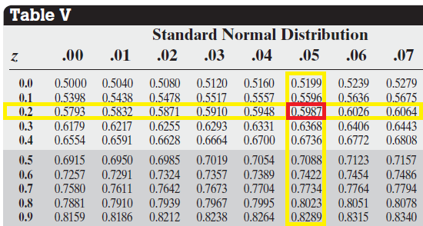
A portion of Table V is shown to the right.

Our goal is to find the area corresponding to
the value of 0.25.

So, we locate the row corresponding to the
value of the tenths place of 0.25 in the first column.

That would be 0.2.

Next, we go to the column corresponding to the
value of the hundredths place, which is .05.

As you can see, the corresponding area to the z-score of 0.25 is 0.5987.

NOTE: The areas displayed in the middle of Table V represents the area to the LEFT of the specified z-score.

So, since our original question was pertaining to finding the area to the right of the z-score 0.25, then the answer is that corresponding area subtracted from 1. Now, we have 1 – 0.5987, which is 0.4013.

Thus, the area under the standard normal curve that lies to the right of 0.25 is 0.4013.
Similarly, P(z > 0.25) = 1 – P(z < 0.25) = 1 – 0.5987 = 0.4013.

Exercises:
Use Table V to obtain the areas under the standard normal curve. Sketch a standard normal curve and shade the area of interest in each problem.
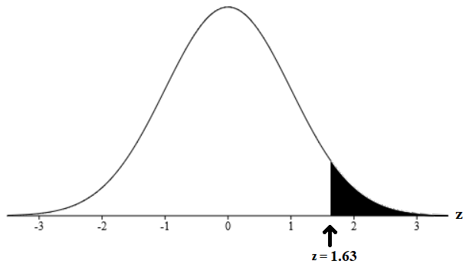
9) Determine the area under the standard
normal curve that lies to the right of 1.63.

$$P(z>1.63)=1-P(z<1.63)=1-0.9484=0.0516$$

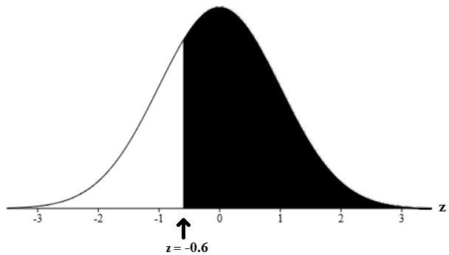
10) Determine the area under the standard
normal curve that lies to the right of –0.6.

$$P(z>-0.6)=1-P(z<-0.6)=1-0.2743=0.7257$$

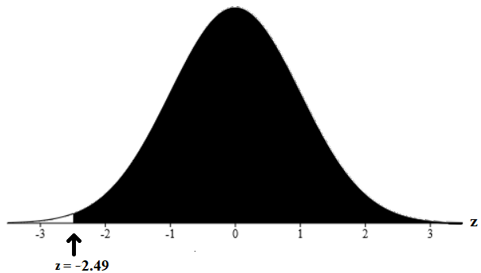
11) Determine the area under the standard
normal curve that lies to the right of –2.49.

$$P(z>-2.49)=1-P(z<-2.49)=1-0.0064=0.9936$$

Use Table V to obtain the areas under the standard normal curve. Sketch a standard normal curve and shade the area of interest in each problem.

Example #3:
Determine the area under the standard normal curve that lies between –1.58 and 2.41.

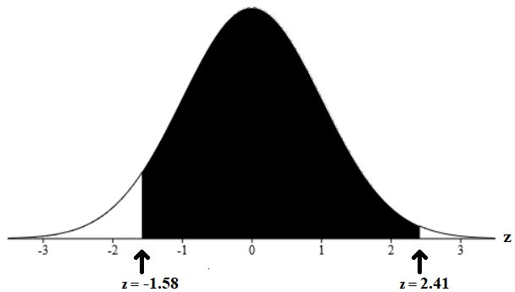
Symbolically, we can write P(–1.58 < z < 2.41).

Shade the region of interest on the standard normal curve
as shown in the figure to the right.

Now, we look at Table V.

Portions of Table V are shown below.

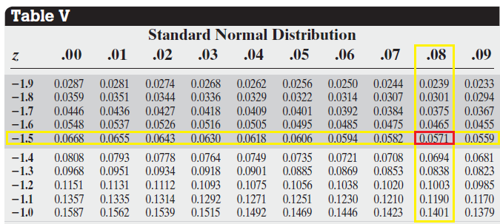
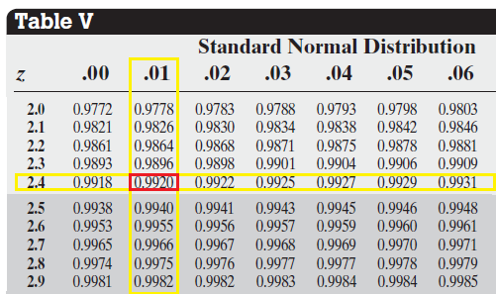

Our goal is to find the areas corresponding to the values of 2.41 and –1.58.

So, for the z-score of 2.41, the corresponding area is 0.9920.

For the z-score of – 1.58, the corresponding area is 0.0571.

NOTE: The areas displayed in the middle of Table V represents the area to the LEFT of the specified z-score.

So, since our original question was pertaining to finding the area in between the z-scores of –1.58 and 2.41, then the answer is the difference of the two corresponding areas which is 0.9920 – 0.0571 = 0.9349.

Thus, the area under the standard normal curve that lies in between –1.58 and 2.41 is 0.9349.
Similarly, P(–1.58 < z < 2.41) = P( z < 2.41) – P(z < –1.58) = 0.9349.

Exercises:
Use Table V to obtain the areas under the standard normal curve. Sketch a standard normal curve and shade the area of interest in each problem.
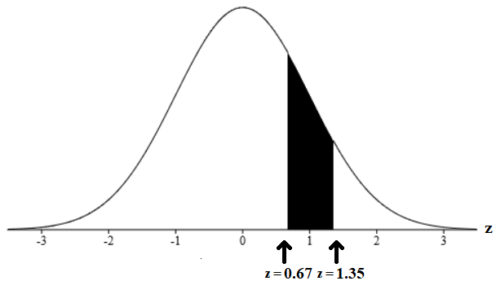
12) Determine the area under the standard
normal curve that lies between 0.67 and 1.35.

$$P(0.67<z<1.35)=P(z<1.35)-P(z<0.67)=0.9115-0.7486=0.1629$$

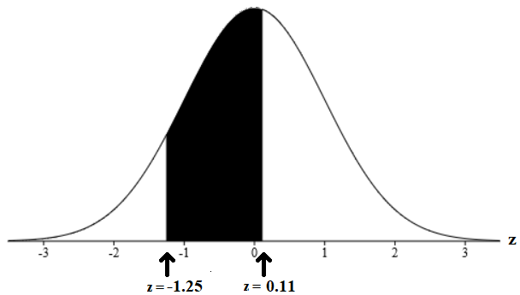
13) Determine the area under the standard
normal curve that lies between –1.25 and 0.11.

$$P(-1.25<z<0.11)=P(z<0.11)-P(z<-1.25)=0.5438-0.1056=0.4382$$

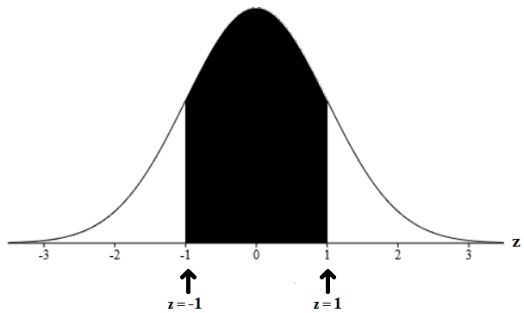
14) Determine the area under the standard
normal curve that lies between –1 and 1.

$$P(-1<z<1)=P(z<1)-P(z<-1)=0.8413-0.1587=0.6826$$

Exercises:
For exercises 15 and 16, use Table V to obtain the areas under the standard normal curve. Sketch a standard normal curve and shade the area of interest in each problem.
15) Determine the area under the standard
normal curve that lies to the right of –4.15.

$$P(z>-4.15)≈1$$

16) Determine the area under the standard
normal curve that lies to the left of –5.23.

$$P(z<-5.23)≈0$$

17) The length of human pregnancies from conception to birth approximates a normal distribution with a mean of 266 days and a standard deviation of 16 days. What proportion of all pregnancies will last more than 300 days (roughly 10 months)?

$$P\left(X>300\right)=P\left(\frac{X-μ}{σ}>\frac{300-266}{16}\right) \\ =P\left(z>2.13\right) \\ =1-P\left(z<2.13\right) \\ =1-0.9834 \\ =0.0166 or 1.66\%$$

